GUDLAVALLERU ENGINEERING COLLEGE
(An Autonomous Institute with Permanent Affiliation to JNTUK, Kakinada)
Seshadri Rao Knowledge Village, Gudlavalleru – 521 356, Krishna District
Department of Electronics and Communication Engineering

Registration for B. Tech Main Project Work

Academic Year: 2020-2021

Date: 22-03-2021
Batch No: C 18
Name of the Students
1. M.A.A.Ansari - 17481A04C9
2. M.Bhagya Raj - 17481A04D1
3. B.Pavan Kalyan - 18485A0431

Broad area of proposed project work IoT and Node MCU

Title of the proposed project work RFID based Smart Trolley using IoT

Block Diagram

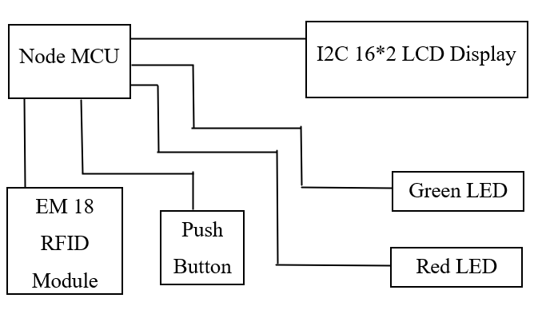
Fig.1: Block Diagram of RFID based Smart Trolley using IOT

Abstract
(Keywords: Node MCU, RFID Module, IoT )

Today’s world has a fast-growing population with a wide range of demand from a variety of domains. Customers who need to purchase different products in Walmart or supermarkets needs lots of time and patience in coordinating among them self for successful shopping. We need to address this problem by efficiently using our technologies. In the advancement of technologies, the world is getting automated in many aspects. In this system, we depict reasonable and cost-effective Smart Shopping Cart utilizing IoT (Internet of Things) innovations. Such a framework is appropriate for use in areas such as Walmart & supermarkets, where it can help in diminishing the work and in making a superior shopping knowledge for the clients. Rather than influencing the clients to sit tight in a long line for looking at their shopped things, this framework helps in mechanizing the easy and comfortable billing process. The shopping is processed with two aspects, with a predefined list and random shopping.

This idea is to develop a system in shopping malls to overcome the above problems. To achieve this, all products in the mall should be equipped with RFID tags and all trolleys should be equipped with a Device which we have made to accelerate the whole process of shopping. Further, we utilize IoT technology for displaying the items purchased in a HTML page connected through common server. We can easily monitor the items we are purchasing and their price. We can also control our expenditure by removing the items which we don’t need in huge quantity. Hence the billing can be done in the trolley itself thereby saving a lot of time to the customers.

Implementation tools required
- Node MCU ESP8266
- EM18 - RFID Reader Module
- REES52 I2C Module
- 16*2 LCD Display
- Push Button
- Red LED
- Green LED

References

- Suraj.S, Vishal Guruprasad, Udayagiri R Pranava, Preetham S Nag, RFID Based Wireless Intelligent Cart Using ARM7 International Journal of Innovative Research in Science, Engineering and Technology, Vol. 5, Issue 8, 2016.
- Komal Ambekar, Vinayak Dhole, Supriya S Smart Shopping Troll Using RFID International Journal of Advanced Research in Computer Engineering & Technology (IJARCET), Volume 4 Issue 10, 2015.
- https://create.arduino.cc/projecthub/electropeak/getting-started-w-nodemcu-esp8266-on-arduino-ide-28184f

- https://www.instructables.com/MFRC522-RFID-Reader-Interfaced-With-NodeMCU/

Signature of the students
1.
2.
3.

Remarks by the Guide

Signature & Name of the guide with date

Signature of B. Tech. with Project Coordinator date

Signature of HoD with date

